The Great American Mountain Rally Revival, Oct 24-27, 2019
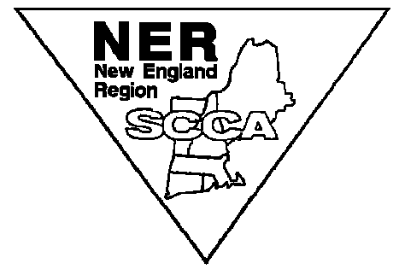The 2nd annual running of the Great American Mountain Rally Revival will be a Regularity rally of approximately 500 miles. A descriptive format will be used for the route instructions. This rally will be a revival of the Great American Mountain Rally which was the first FIA listed rally in the United States and was held between 1953 and 1957. This rally is well suited for inexperienced as well as veteran rallyists. The Great American Mountain Rally Revival will start at the Saratoga Auto Museum in Saratoga, NY and end in Bennington, Vermont. Paved and unpaved roads are utilized. The rally is hosted by the New England Region of the Sports Car Club of America (NER/SCCA).
General: Entry will be limited to 25 cars. General Instructions will be posted on the NER website. www.ner.org .
Registration Dates: Regular Registration June 19-July 25; Late registration July 26-Aug 15
Final Registration and Scrutineering: Thursday Oct. 24, 6:00PM-8:00PM at the Saratoga Auto Museum in Saratoga, NY. Enjoy a private kickoff event at the Museum which includes access to all the exhibits, a museum guide and wine & cheese reception with light hors d’oeuvres (cash bar).
Start: First car off at 8:00 AM Friday Oct. 25 plus car number in minutes.
Finish: Sunday Oct. 27 approx. 2:30 PM, awards ASAP. At Hemmings Motor News in Bennington, VT.
Classes: Based on model year of cars: Original: pre-1958, Classic 1958-1978, Modern: 1979 to Present
Additional information: Call the Rallymaster, Gary Hamilton: 978-500-8039 or gamrrrally@gmail.com (preferred).
REGISTRATION:
Driver______________________________________ Navigator _________________________________________

Street ____________________________________ Street ____________________________________________

City/St/Zip__________________________________ City/St/Zip _________________________________________

Telephone__________________________________ Telephone ________________________________________

E-mail Address_______________________________ E-mail Address _____________________________________

Shirt Size_______________________________ Shirt Size _____________________________________

Vehicle Make_________________ Model_________________ Year_______ Plate #_____________State_____

Registration Fee (per vehicle): ___ $1,850 for entries postmarked by July 25, 2019.
___ $2050 for entries postmarked July 26-Aug 15, 2019. No entries after Aug 15.
Includes Thursday, Friday and Saturday night hotels, breakfasts, Saturday dinner, route instructions, rally plates, GAMRR Rally attire, door stickers, sweep truck services, rally school, and awards.
Mail entry form and fee payable to “New England Region, SCCA, Inc.” to GAMRR 2019 c/o Gary Hamilton
2 Dunkirk Rd
Ipswich, MA 01938

Cancelation policy: Due to lodging deposit requirements, any cancelations after July 25 will be reduced by $500.00
THIS EVENT WILL BE CONDUCTED IN ACCORDANCE WITH THE 2015 NER-SCCA RALLY REGULATIONS. THE ENTRANT WARRANTS THAT AN AUTO INSURANCE POLICY WITH LIABILITY LIMITS AS REQUIRED BY THE STATE IN WHICH THE VEHICLE IS REGISTERED IS IN FORCE FOR EACH VEHICLE ENTERED. THE ENTRANT CERTIFIES THAT THE CAR ENTERED IS ON THE ROAD LEGALLY AND IS EITHER OWNED BY THE ENTRANT OF IS BEING USED BY THE ENTRANT WITH THE OWNER’S PERMISSION. IN SIGNING THIS FORM, I AGREE TO ABIDE BY ALL THE REGULATIONS AND DECISIONS OF THE RALLY COMMITTEE. IF EITHER THE DRIVER OR NAVIGATOR IS UNDER 18, A MINOR RELEASE FORM MUST BE OBTAINED AND SIGNED BY BOTH PARENTS IN THE PRESENCE OF THE REGISTRAR OR A NOTARY PUBLIC.

